1.Project Title :- Plasma Donor App with aws Serverless Computing

2. Introduction

2.1. Overview:-

In this Plasma donor app, you can Registration with username, email, password, phone number, choose also infected or not infected category also then it all data entry on DynamoDB, you can also run this project on local host and also SMS send features using fast2sms api for concern people.

2.2 Purpose:-

It's purpose is help to covid-19 patients to find donor of plasma with this plasma donor app with its SMS features.

3 Results

3.1 Screenshots of outputs:-

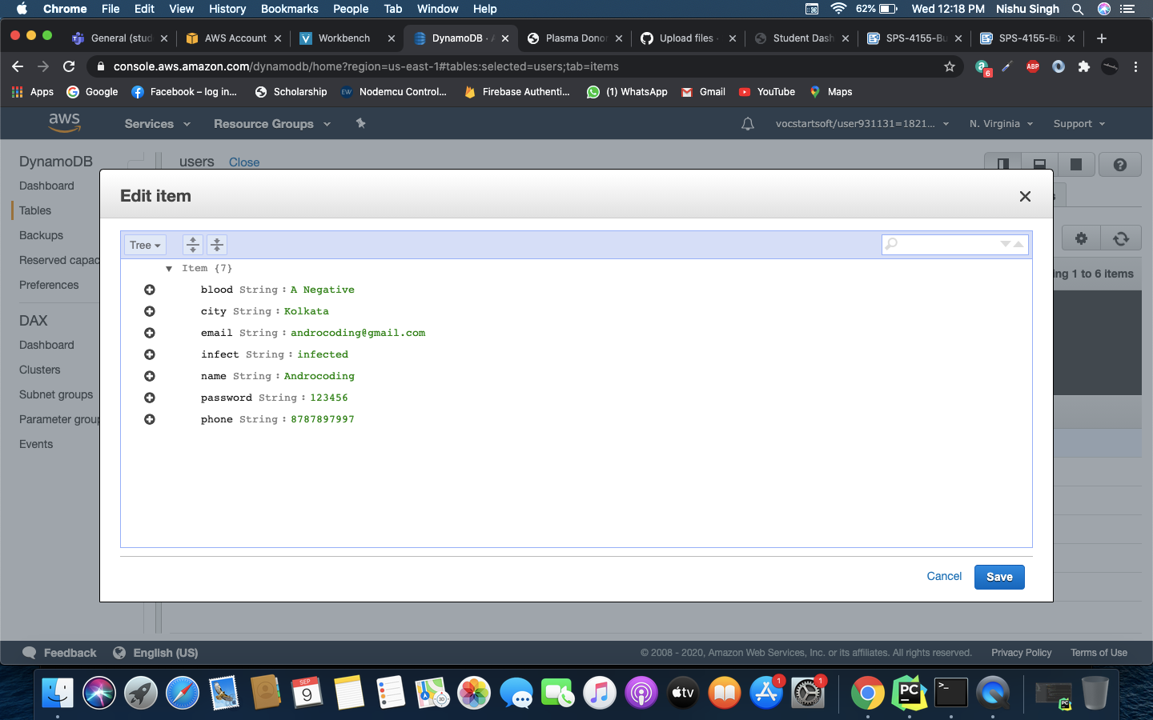

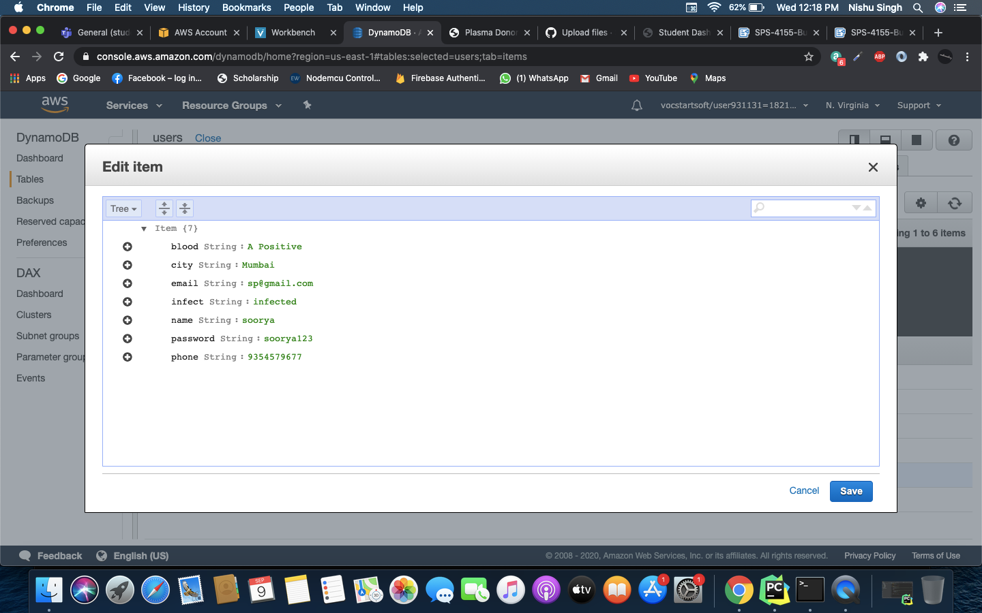

Application:-

its help to find donor.

its uses in hospitals .

Conclusion:-

It concludes overall projects learn to help aws serverless computing functionality likes DynamoDB, Lambda function, Iam.

Future Scope:-

In the future, It helps to hospital management to find donor plasma and records of donor and request to plasma that it easily access and contacts.

Also add new features add on Plasma Donor app implements Machine learning that help to correct user and send SMS on time.